**NUCLEAR RADIATION DETECTOR**

**Using ki-cad**

**SCHEMETRIC DIAGRAM:**

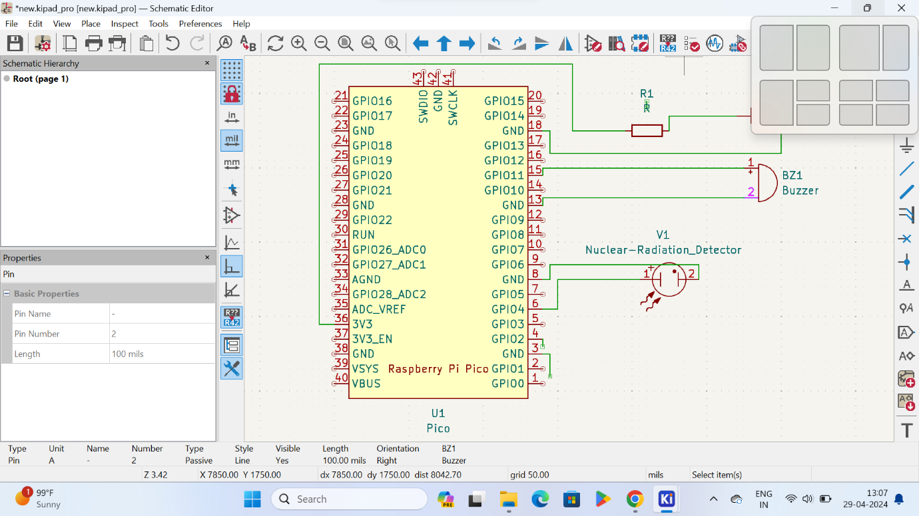

**PCB LAYOUT:**

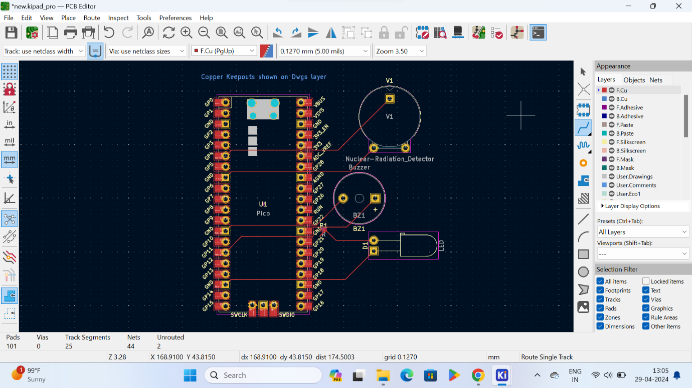

**3D VIEW OF PCB LAYOUT:**

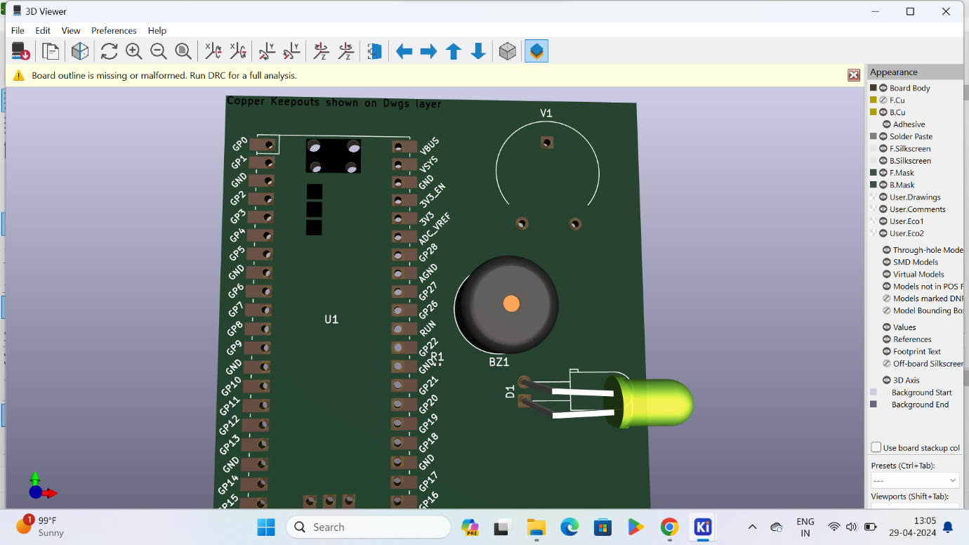

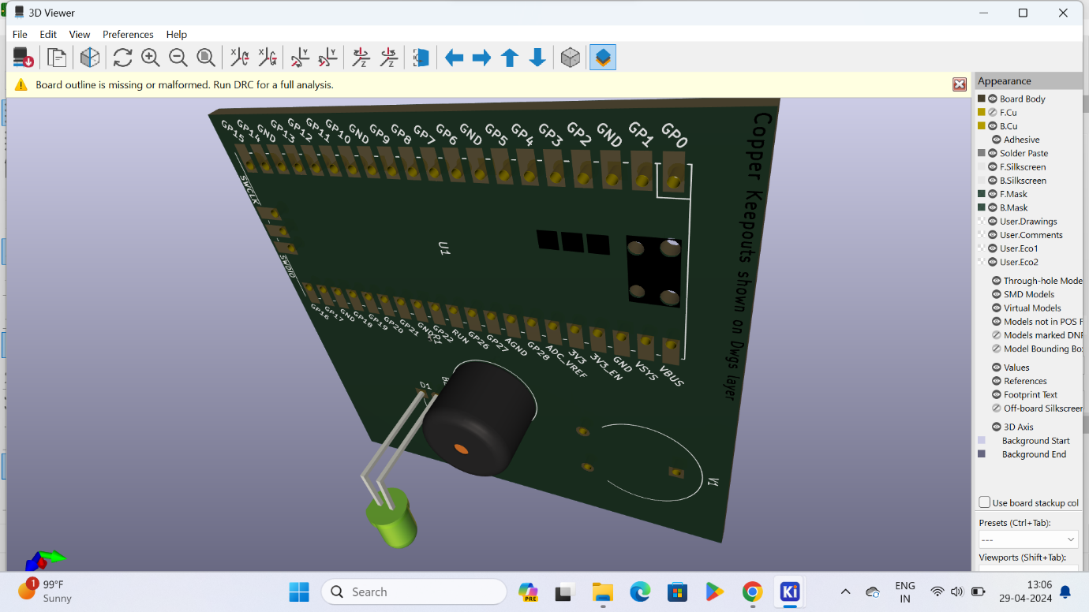

**BACKSIDE VIEW OF 3D VIEW:**

